

Lab 1B: Draw a Square

# Course Learning Outcomes:

CLO 1 Describe the fundamental structures of an agent-based programming language

CLO 2 Solve a problem by using an agent-based programming language

CLO 3 Compose logical structures (algorithms) to produce an adequate solution for a problem

# Module Learning Objectives:

Install the NetLogo program, or access NetLogo online by creating programs with it. (CO 2)

Creating a comment header. (CO 3)

Practice using basic commands in NetLogo (CO 1)

Create a sense of classroom community

# ASSIGNMENT:

Use NetLogo Turtle Graphics to draw a simple square of size 4. This is done by using two turtle commands: forward and right, in a procedure called by a NetLogo “go” button. Note that one click of the button should draw the whole square. Meaning that program will need to use more than one forward and right command. The drawing will look line the screen captured below,

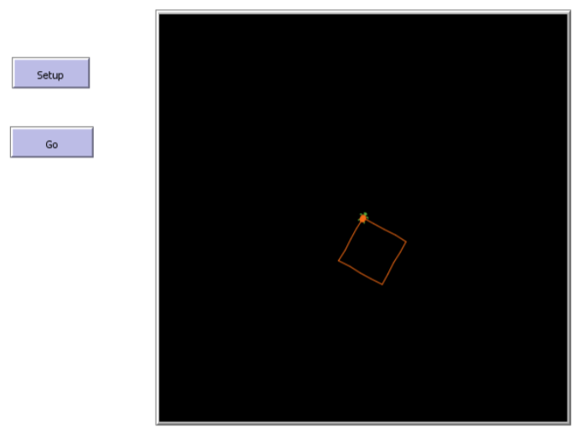

In the example shown above, the “setup” button calls a procedure that clears NetLogo’s model view plane. The “go” button calls the “go” procedure, which instructs the turtle to move forward and turn enough times to draw an enclosed square. By clicking setup then go, a square of size 4 will be created.

# Grading Rubric [100 points total]:

[A: 2 points]: Name the program: lab1B_square.nlogo and submit the nlogo file to Brightspace.

[B: 18 points]: Include a header at the top of your code. Refer to the following example:

; Author: **[Student’s first and last name]**

; Due Date: **[the due date]**

; Title: Lab1B: Draw a Square

; School: Central New Mexico Community College

; Course Number: CSCI 1108, Section 101

; Course Title: CS for All: Introduction to Computer Modeling

; Semester: Summer 2020

; Instructor: Sherlock Holmes

[C: 40 points]: Create two procedures, setup and go, and two buttons, also named setup and go.

[D: 40 points]: The code should draw the square of size 4 when the buttons are pressed.